# Models for synchrophasor with step discontinuities in magnitude and phase, their parameter estimation and performance

Marcelo Britto Martins*, Renata Teixeira de Vasconcellos*, Paulo Antonio Andrade Esquef†

### *National Institute of Metrology, Quality and Technology - Inmetro

mbmartins@inmetro.gov.br, rbvasconcellos@inmetro.gov.br

†National Laboratory for Scientific Computing – LNCC

Paulo Antonio Andrade Esquef

pesquef@lncc.br

### *Abstract* — This work proposes an alternative method to assess the calibration of phasor measurements units (PMUs) under magnitude and phase step conditions. Two parametric mathematical models are used to represent the signal and an iterative numerical method is used to best fit the model parameters to the samples. This approach avoids the adjustment of time windows around the instant of the discontinuity. The estimated parameters can be used to calculate a reference phasor with an appropriate definition. Expand a little more

### *Index Terms* — Calibration, dynamic tests, phasor measurement units, synchrophasor, uncertainty.

### I. Introduction

PMU calibration systems must be able to perform magnitude and phase step tests to evaluate the response of such devices under dynamic conditions [1], including magnitude and phase step tests. The accuracy of those measurements depends on the reference values provided by the calibration system, obtained by synchronously generating and sampling the standard test signals. Recent developments towards the calibration of PMUs for distribution systems demand even lower uncertainty levels [2].

Hilbert transform has been used to detect audio editions [] and electric disturbances []. The detection is based on extracting the instantaneous frequency of the signal. Significant disturbances cause a peak in the time frequency distribution obtained, which position can be estimated by some peak detection or threshold function.

A stationary waveform can be curve fitted with a steady state sinusoidal function with good accuracy. However, in the specific case of the time window containing samples from an underlying signal disturbed by a step discontinuity in magnitude or phase, there is a lack of definition of what the reference phasor should be. To overcome this difficulty, the method used in [3] adjusts the timestamp and position of the analysis window to skip the discontinuity and set the phasor estimates where the discontinuity occurs with those of obtained from the previous window. That way, it avoids the mathematical modelling of a step discontinuity.

This work is an extended version of []. It offers the following contributions: 1) synchrophasor models that account for step discontinuities in magnitude and phase; 2) a way to estimate the instant of step occurrence; 3) a way to estimate model parameters by means of a nonlinear least-square method (NL-LS); 4) proposition of single phasor parameters for transient situations.

### II. Mathematical models

A waveform with one magnitude step can be modeled as

$\hat{y}(t)=x_{1}\left[1+x_{2}u\left(t-τ\right)\right]\cos\left(ωt+φ\right)+ η\left(t\right)$, (1)

and the waveform with one phase step as

$\hat{y}(t)=x_{1}\cos\left(ωt+φ{+ x}_{3}u\left(t-τ\right)\right)+ η\left(t\right)$. (2)

The step function $u\left(t-τ\right)$ is used as an idealization of a fast jump in magnitude or phase occurring at the instant $τ$.

What is a Hilbert transform and how the instantaneous frequency obtained by a Hilbert filter can detect phase and magnitude steps??

Provided a good estimation of $τ$, the set of parameters $P=\{x_{1},x_{2},x_{3}, ω,φ\}$ can then be adjusted to obtain a waveform that best fits the data received by the calibration system sampler, where $x_{1}$ is the signal nominal magnitude, $x_{2}$ is a decimal value representing the magnitude change, $x_{3}$ is the amplitude of the phase step, $ω$ is the angular frequency, $φ$ is the initial phase, and $η(t)$ represents interfering noise. Given a signal to noise ratio (SNR) in dB, the amplitude of noise is

$η_{0}{{=(x}_{1 }}/{{ 10}^{{SNR}/{20}}). }$ (3)

Taking *N* samples $y\left(k\right)$ with sampling interval $∆t$, and the sum of squared errors

$ε\left(P\right)=\frac{1}{2}\sum_{k=1}^{N}{{\left(y\left(k\right)-\hat{y}\left(k∆t\right)\right)}^{2}}$, (4)

an estimation of $P$ can be obtained solving the minimization problem $\min_{P}{ε\left(P\right)}$, which will be briefly discussed in the next section.

IV. STEP INSTANT ESTIMATION

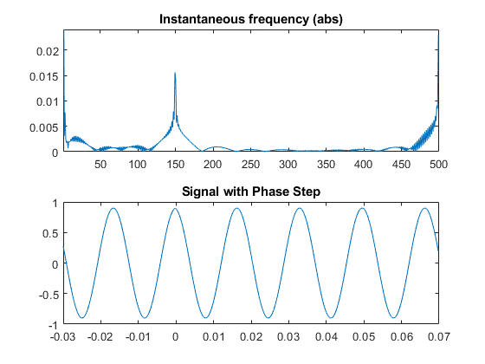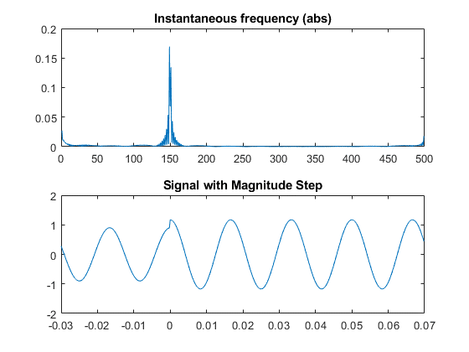The estimation of $τ$ can be done by tracking the peaks of the estimated instantaneous frequency obtained by a Hilbert filtering of the sampled signal. For a total duration of the window *T*, $τ∈\left[0.05T,0.95T\right]$, and $SNR>40dB$, the maximum absolute errors are not greater than one $∆t$.

### III. Parameters estimation

The Levenberg-Marquardt (LM) algorithm is an iterative technique for nonlinear minimization problems. It combines the Gauss-Newton method and the steepest descent and is very useful when the size of the algorithm step cannot be obtained in a closed form. Such NL-LS methods can reach local minima and need a convex cost function.

Figure of the cost function

Maybe explain more about LM

To check if the convergence is acceptable within certain limits, taking into account the uncertainties of the system and different noise levels, a Monte Carlo simulation was performed with 1000 iterations for each SNR. For this analysis, the step discontinuities occur in the middle of the window ($τ=0.5T$).

For each Monte Carlo iteration, $y\left(k\right)$ is generated with uncertainties added to the parameters, drawn from a uniform distribution centered around the nominal values, as shown in the upper part of Table I, where **d** is the interval of the uniform distribution, given in ppm. In the iterative LM algorithm, the model parameters are initiated at the nominal values, and the optimization procedure seeks for the minimum point of $ε\left(P\right),$ which is reached at the actual values of the parameters. In all simulations the sampling frequency was set to 4800 Hz, and the analysis window covers 6 cycles of the nominal phasor. The maximum errors obtained are shown in the lower parts of Table I. One can see that, for both tests, the estimation of the step discontinuity parameters are the most sensitive to the SNR. Moreover, they exhibit the highest maximum errors.

Table I- Parameter estimation maximum errors as a function of the SNR

|  |  |  |  |  |  |
| --- | --- | --- | --- | --- | --- |
| **Parameter** | $$x_{1}$$ | $$x_{2}$$ | $$x_{3}$$ | $$ω$$ | $$φ$$ |
| **Nominal** | 100 V | 0.1 | 10° | 60 Hz | 120° |
| **d[ppm]** | 200 | 200 | 200 | 100 | 100 |
| **SNR** | **Magnitude Step Tests maximum errors [ppm]** | | | | |
| 97 | 0.98 | 12 | - | 0.077 | 0.30 |
| 95 | 0.95 | 15 | - | 0.086 | 0.33 |
| 93.5 | 1.2 | 20 | - | 0.087 | 0.50 |
| 92.5 | 1.5 | 19 | - | 0.087 | 0.53 |
| 90.5 | 1.8 | 32 | - | 0.15 | 0.50 |
| **SNR** | **Phase Step Tests maximum errors [ppm]** | | | | |
| 97 | 0.54 | - | 16 | 0.13 | 0.67 |
| 95 | 0.71 | - | 19 | 0.17 | 0.69 |
| 93.5 | 0.89 | - | 22 | 0.18 | 1.0 |
| 92.5 | 0.96 | - | 23 | 0.18 | 1.2 |
| 90.5 | 1.1 | - | 28 | 0.22 | 1.4 |

The uncertainties of some parameters seem to be correlated. For example, in the phase step test model, the uncertainty in the

angular frequency ( $ω)$ estimation (all other parameters kept constant) has a quadratic relation with the maximum error obtained for the magnitude parameter ${(x}_{1})$, as shown in Fig. 1.

Fig. 1. Maximum error of the magnitude parameter as a function of the frequency uncertainty

V. Reference values

After one estimates the model parameters, the problem of obtaining one phasor that represents the waveform arises. Instead of considering the values estimated from the adjacent windows, one alternative proposal could be an intermediate value for magnitude or phase. That can be obtained, for example, using a weighted means out of the model parameters. The concept is illustrated in Figure xx, where the phasor V1 represents the waveform during an initial steady state, Ve is a phasor representative of an intermediate state during the occurrence of a magnitude or phase step, and V2 represents the signal in the final steady state condition.

V2

V2

Ve

Ve

V1

V1

a)

b)

Figure xx – Transitioning phasors for a) magnitude step, b) phase step

For any $τ∈\left[0,T\right]$, for a waveform with magnitude step described by equation (1), the intermediate magnitude would be

$X_{e}=\frac{{\hat{x}}_{1}\hat{τ}+{\hat{x}}_{1}(1+{\hat{x}}_{2})\left(T-\hat{τ}\right)}{T}$; (5)

and for a waveform with a phase step test described by equation (2), the intermediate phase would be

$φ_{e}=\frac{\hat{φ}\hat{τ}+\left(\hat{φ}+{\hat{x}}_{3}\right)\left(T-\hat{τ}\right)}{T}$. (6)

To estimate the sensitivity of magnitude and phase obtained by the methods described in the last sections, a Monte Carlo simulation was performed, with SNR of 90.5 dB, the uncertainties indicated in Table I and also considering errors in the estimation of $τ$. The maximum errors obtained for both were not greater than 2 ppm. Then, considering this value as the uncertainty contribution of the estimator is a conservative approach.

VI. Real Measurements

Explain the setup for real measurements…

Block diagram figure

Explain how measurements were taken…

Discuss the results, uncertainties, estimation parameters

V. Conclusion

Models for phasor signals disturbed by magnitude and phase step discontinuity were proposed, in the context of assessment of PMU calibration systems in transient conditions. Estimation of the model parameters via a nonlinear least-squares method was outlined. The proposed approach tackles the estimation of the step discontinuities in the phasor signal observed within an analysis window, instead of dodging the problem. Moreover, single phasor parameters are proposed for transient conditions.

The estimation accuracy of each parameter was obtained under different noise conditions and uncertainties forced upon the model used to generate the test signals. Cross-correlated uncertainties were found, which point out to the need of a deeper investigation and the possibility of further improvements in the estimation performance.

Within the limits reported, the proposed method can give reliable and accurate results to be used in PMU calibration systems, avoiding procedures to adjust windows and time-stamps around the instant of step occurrence.

### Acknowledgement

I would like to thank Allen Goldstein, Dr. Renata Vasconcellos and Dr. Paulo Esquef, for the valuable comments and guidelines.

### References

[1] *IEEE Standard for Synchrophasor Measurements for Power Systems*, IEEE Std C37.118.1-2011*,* Dec. 2011

[2] D. Colangelo *et al*., "Architecture and characterization of a calibrator for PMUs operating in power distribution systems," *2015 IEEE Eindhoven PowerTech*, Eindhoven, 2015.

[3] Y. H. Tang, G. N. Stenbakken and A. Goldstein, "Calibration of Phasor Measurement Unit at NIST," in *IEEE Transactions on Instrumentation and Measurement*, vol. 62, no. 6, pp. 1417-1422, June 2013.